Concerts are held at Crofton Country Club from 6-8 PM

June 4, 2023: Pocket Change ~ Easy Listening
June 11, 2022: Goodfella’s ~ Beatles Revue
June 18, 2023: Bay Jazz Project ~ Jazz
June 25, 2023: Wicked Olde ~ Pop to Folk
July 2, 2023: Sandra Dean Band ~ Classic Rock
July 9, 2023: Six Pack Rodeo ~ Country with a Kick
July 16, 2023: Moxie Blues ~ Blues
July 23, 2023: 40 Dollar Fine ~ Rock ‘N’ Soul

The Summer concert series is provided by the Crofton Civic Association
and a grant from the Arts Council of Anne Arundel County.
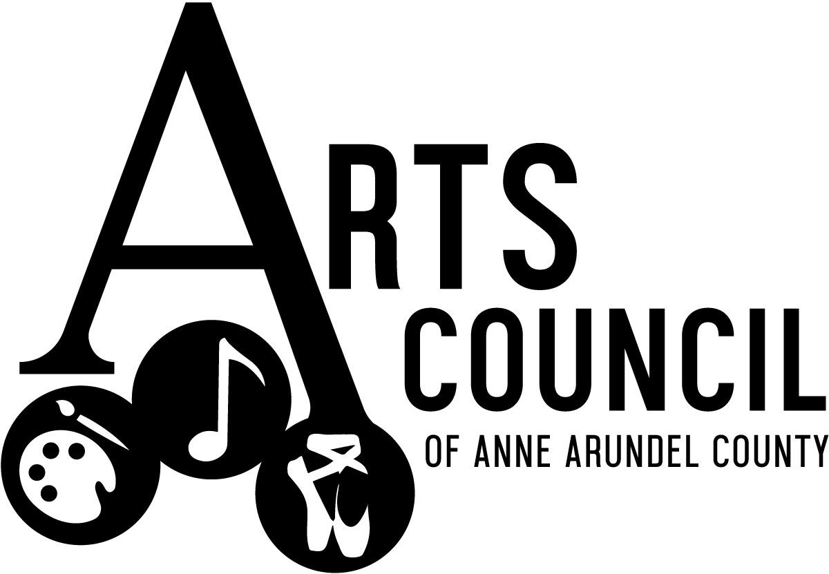
Bring chairs or a blanket as no seating is provided on the grass.
